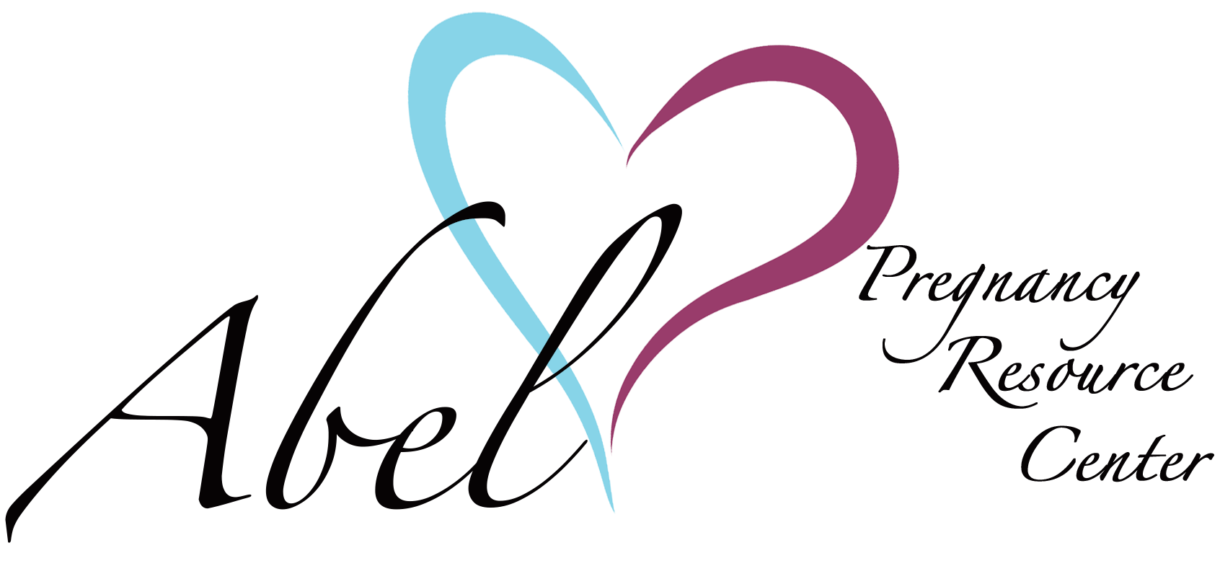

Dear Master’s Open Golf Tournament Volunteer,

First and foremost, I want to say thank you. Thank you for giving of your time, energy and enthusiasm at the 2023 Master’s Open Golf Tournament. It was a pleasure to have you on the team as we did our very best to provide excellence to our competitors.

It is that time of year again, where we reach out to you and additional potential volunteers. Our hope is that you will be able to join us again and others in the community will too.

The tournament will be held on the 27th of July, 2024 at Fountain Springs Golf Course in Peterstown, WV. We have thoroughly enjoyed working with Steve Newberry and his team and again this year, Steve is rolling out the red carpet for our event.

I will be creating a webpage where everyone can see the areas of need so that a clear picture will be readily available for making plans on your end.

I will be in touch soon with details in the very near future. If you know others in your sphere of influence with friends and family please ask them if they too would like to participate as a volunteer. We’re going to need all hands on deck once again in 2024 to make the tournament a grand success.

Thank you and God bless you.

Sincerely,

Matthew Schaetzle
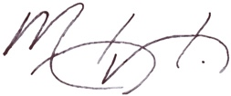

Executive Director
Abel Pregnancy Resource Center
201 Sylvia Lane
Bluefield, WV 24701
304-325-2000
info@abelcenter.org
www.friendsofabel.org
www.aprcfundraiser.org

